**Simulation Lab - 2**

**Date: 14 July 2020**

1. Find the value of PI using Buffon’s Needle Experiment. Understand the Buffon’s Needle Experiment and implement the process using Python. Use 500, 1000, 5000 points to see the result. Assume d=2 and l=4 for the experiment. Draw the Scatter Plot graph to show the points of hit and miss.

The plot will be like this:

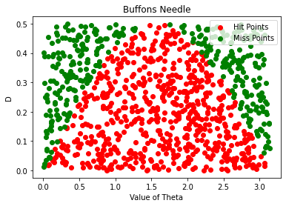

1. Find the value of PI using Monte Carlo simulation. Understand the Monte Carlo Method and find the value of PI using the method on Python. Use 500, 1000, 5000 points to see the result. Draw the Scatter Plot graph to show the hit and miss points.

The plot will be like this: (For 1000 points)

